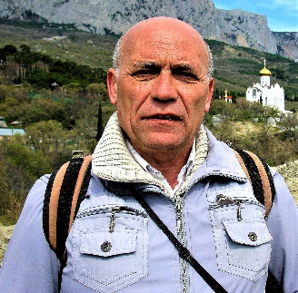

Features of the cold seeps of Laspi Bay (South Coast of Crimea)
Lysenko, Vitaliy
Moscow State University, Sevastopol Branch – niagara_sev@mail.ru
Phone Number: +79787209128

Abstract:

There is a link between climate change on Earth and the release of hydrocarbon compounds into the atmosphere. Some of them come from cold seeps from the bottom of the seas and oceans. In Laspi Bay, seeps are located at depths of up to 3 m. Gases from them are released into the atmosphere. This study presents the results of a fluid study from seeps in Laspi Bay.
During different observation periods, from 8 to 20 gas bubble releases are observed. Their flow rate is not constant, ranging from 2.6 to 20.3 mL/min. The composition of gases and fluids changes over the course of an hour or a day. It was determined on a Chromatek-Crystal 5000 gas chromatograph. The fluid gases were represented by: CH₄ (55.7–60.4%), C₂H₆, C₂H₄, C₃H₈, C₃H₆, C₄H₁₀, C₅H₁₂, N₂ (9.62–40.01%), O₂ (0.14–14.81%), CO₂ (0.12–0.46%), He (0.0047–1.1901%), CS₂ (0.16–0.46%), H₂S (0.031–0.053 ppm), and COS (0.042–0.081 ppm).
Fluids are accompanied by aqueous solutions. The salinity of seawater in Laspi Bay is 18.8‰, while the salt content in aqueous solutions is less than 9.5‰. Aqueous fluid solutions differ from seawater in the content of geochemical elements. According to the results of five analyses, the content of Br, B, Sr, Si, Li, Mn, Se, As, Hg, Be, Ti, Ga, Ge, As, Zr, Os, Pt, Au, Te, Cs, Ba, Bi, Th and U is higher than in the seawater of Laspi Bay. In contrast to aqueous solutions, seawater from Laspi Bay is characterized by elevated contents of Al, Fe, Rb, Y, Mo, Sn, Zn, Cu, Ni, Co, Cr, Pb, and Hf.
As a result of the research, the features of the multicomponent gas composition of fluids and the presence of aqueous solutions in them were established for the first time.

Biography:

Candidate of Geological Sciences graduated from the Sverdlovsk Mining Institute. He defended his PhD in Geology at the Institute of Geological Sciences in Kyiv. Previously, he worked as a geological engineer in the Ministry of Mining in Kazakhstan, Central Asia, Chita and Magadan regions. His dissertation was devoted to the Lower Cretaceous volcanism of the southwestern Crimea. He currently lectures on geology and paleogeography at the Sevastopol Branch of the Lomonosov Moscow State University. His research interests include paleovolcanism, processes of hydrocarbon gas influx from the earth's interior, and modern and ancient hydrocarbon seep carbonates. He has published a number of articles in peer-reviewed journals.

